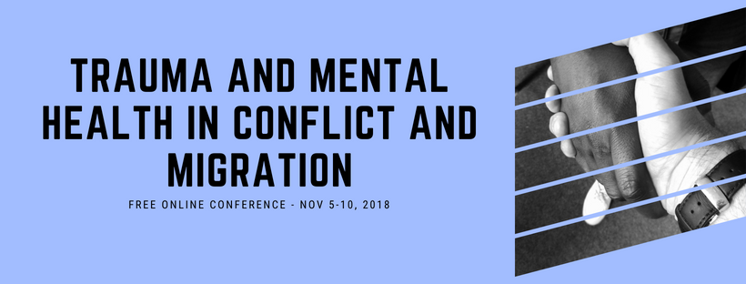

Mike Niconchuck

Bringing neuroscience education into dynamic field settings

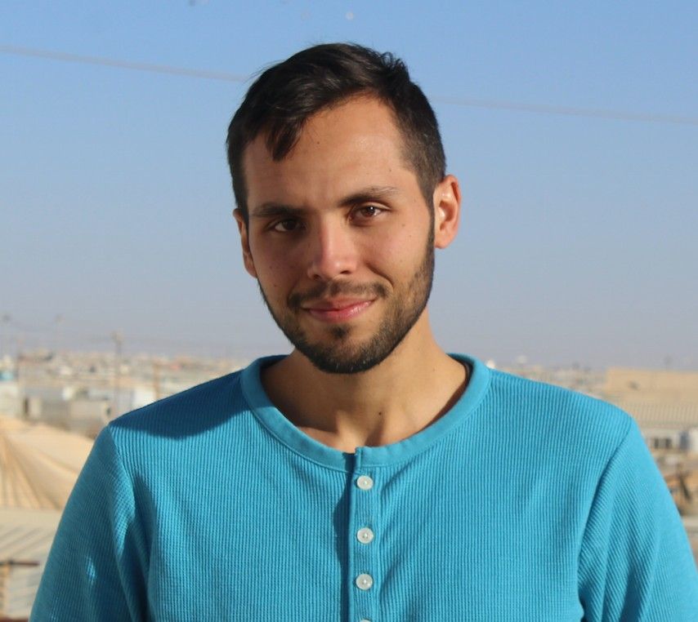

Neuroscience, Conflict and Peacebuilding

Cognitive science has advanced dramatically in the past 20 years, giving us unprecedented insight into how the human brain works to promote cooperation and peace building on one hand, and conflict and division on the other.

Despite advances, we still only have an emerging picture about the relationship between conflict, resilience, reconciliation, and the brain. Perhaps more than any other sub-field in the brain and behavioral sciences, mental health researchers have spent decades mapping how conflict can disrupt various processes in the brain and body, including emotion, social cognition, and behavior. Importantly, though so much of the work in neuroscience and peace building remains isolated from affected communities, and isolated from practice in humanitarian aid and conflict work.

Mike Niconchuck will discuss the complications and possibilities of bringing neuroscience education into dynamic field settings, and assess the role that psychoeducation may play in dealing with broader mental health issues in communities affected by conflict. He will use Beyond Conflict’s innovative Field Guide for Barefoot Psychologists as a case study in this regard.

Mike Niconchuk is the Senior Researcher at Beyond Conflict's Innovation Lab for Neuroscience and Social Conflict in Boston, MA. Since joining Beyond Conflict in June 2017, Mike has spearheaded the startup of the Innovation Lab, establishing project design and monitoring systems that merge tools and practices from social neuroscience, social psychology, and conflict resolution fields. Specifically, Mike leads several research and science-informed design projects in the Lab under the Refugee & Migrant Crisis Initiative focusing on the neuroscience of trauma and the biology of social belonging and exclusion, to transform government and international institutions’ response to the Syrian refugee crises, counterterrorism and countering violent extremism, and racial injustice and tension in the United States.
Copyright © 2018 Psychology for Peacebuilding, All rights reserved.

Our mailing address is: Psychology for Peacebuilding Prague
Praha 4, Czechia 14000

