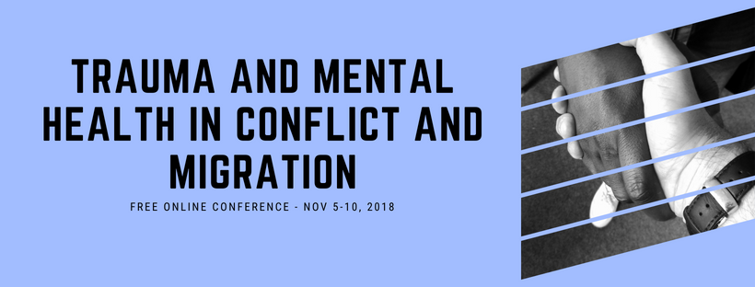

Shrusti

The elephant in the room: Vicarious Trauma

To take care of others, we must take care of ourselves..

In our work as peace builders we come across stories everyday - stories of pain, of injustice and of suffering. As advocates or activists we do everything in our power to undo the suffering of others, to fight for justice and relieve pain. But how often do we turn this compassionate gaze onto ourselves? Secondary trauma is real and when ignored it can result in disastrous consequences not only for ourselves but also for the people who need us to stand in solidarity with them the most. Join us as we explore what vicarious trauma is and discuss ways to build a healthier more (self) compassionate peace building community.

Srushti is young peace builder from India with a focus on women peace and security in fragile states. She studied her Bachelor’s in Psychology and her Masters in gender studies, and has been working and conducting research with different NGOs over the past 8 years and has worked with victims of sex trafficking, women survivors of violence in DRC and human rights defenders in other parts of Africa. She is now working in Houston, providing advocacy to survivors of violence at a women's shelter. Srushti always felt that trauma work was never done well or done enough.

Copyright © 2018 Psychology for Peacebuilding, All rights reserved.

Our mailing address is: Psychology for Peacebuilding Prague
Praha 4, Czechia 14000

