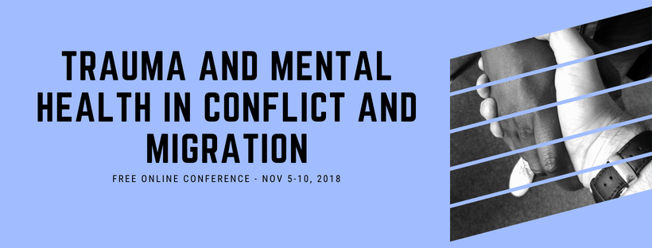

Meba Alphonse Kanda, M.D.
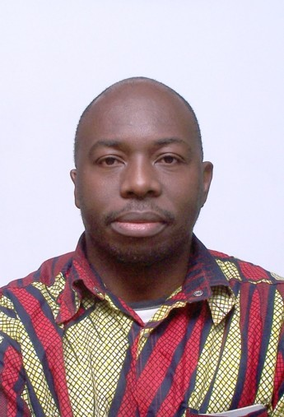
A Logotherapy Perspective of Community Mental Health: The case of rural mental health in South Africa

The collision of epidemies in Africa occurs in an historical environment of violence, poverty and displacement. The suffering resulting from such a traumatic historical context and the co-existence of communicable and non-communicable diseases presents a real challenge to the existential questions about life for the sufferers and the witnesses of suffering such as health professionals and researchers.

This presentation proposes that ignoring or overlooking the existential questions raised in a context of suffering, illness and death leads to an existential frustration with a mode of engagement or being which is based on will to power,will to pleasure and no will to live. Such existential modes of engagement result into aggression, addiction and depression and constitute a source of further suffering and violence. The presentation uses logotherapy as a meaning centred existential anthropology which proposes the interplay of health, peace and development, using the case of rural mental health practice in South Africa. Such a meaning centred existential anthropology provides also pathways to health, peace and development despite the context of violence and suffering with a collision of epidemies.

Originating from the Congo (DRC) where he completed his medical studies with additional four-year postgraduate training in Neuro-Psychaitry. He has been working in psychiatry for more than twenty years.
Following his professional interests, he studied in South Africa while working as medical officer in psychiatry. He obtained a Diploma in Mental Health from the College of Medicine of South Africa, a Clinical Logotherapy Diplomate Certificate from the University of South Africa (UNISA) and The Viktor Frankl Institute of Logotherapy. Working in the Community Mental Health Unit of West Rand Health District in Gauteng/ South Africa as a Principal Medical Officer, he is mainly involved in the mental health outreach programme with particular interests in rural mental health, community development and peace building. He is also a Logotherapy facilitator at the UNISA Centre for Applied Psychology and an
e-tutor for the department of Anthropology at UNISA where his current studies as an Anthropology Master student focuses on psycho-sociocultural interventions in clinical settings.

Copyright © 2018 Psychology for Peacebuilding, All rights reserved.

You are receiving this email because of your interest in the online conference: Towards a Holistic Understanding of Mental Health and Trauma in Migration and Conflict, November 5-10th 2018.

Our mailing address is: Psychology for Peacebuilding Prague
Praha 4, Czechia 14000 United Kingdom

Add us to your address book

Want to change how you receive these emails?
You can update your preferences or unsubscribe from this list.

