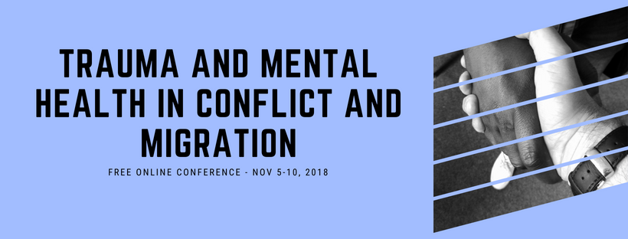
Tarli Young

How can Positive Psychology contribute to the field of peacebuilding / aid work?

A Positive Psychology Approach to Aid Worker Mental Health: The Influence of Resilience, Meaning and Psychological Flexibility on Aid Workers' Wellbeing and Distress with Tarli Young, University of Queensland

Aid workers confront multiple stressors that hinder their ability to deliver aid effectively; such
stressors impact the workers, their organisations and aid beneficiaries. Despite the impactful role of stress, there is limited research on aid worker mental health. Using both qualitative and quantitative methods, we have collected data from over 400 aid workers from diverse backgrounds. The qualitative study identifies key stressors and coping strategies used by aid workers. Four overarching themes emerged across the three research questions: Work, Psychological, Lifestyle, and Social Connection.

Join us as we discuss the most common stressors, effective coping strategies and ideas for interventions.

Tarli Young is currently a PhD Candidate within the School of Psychology at the University of Queensland (UQ). Her PhD Research on enhancing wellbeing among vulnerable, including aid workers. Tarli previously completed a Masters of Applied Positive Psychology (MAPP) at the University of East London (UEL). At UQ, she also lectures in positive psychology and works as a Senior Research Specialist.
Copyright © 2018 Psychology for Peacebuilding, All rights reserved.

Our mailing address is: Psychology for Peacebuilding Prague
Praha 4, Czechia 14000

